Final Project Report

Project Name**: “A D M I R I A “**

Type**: *E-commerce Site***

***Address***[***: https://admiria.000webhostapp.com/***](:%20%20https:/admiria.000webhostapp.com/)

Group Members:

1. ***Jannatun Naima – 162-0680-042***
2. ***Md.Riftabin Kabir -162-0324-042***
3. ***Md. Nazmul Hosain-1530607042***
4. ***Md. Rabbi Amin- 1611233042***
5. ***Md: Israfil Pramanik-1421121042***

Course: ***CSE327***

Section: ***11***

Instructor: ***Sarker Tanveer Ahmed (TAR)***

Submitted To: Sarker Tanveer Ahmed (TAR)

Submitted On: ***31.12.18***

**Table of Contents:**

|  |
| --- |
| Use cases |
| Use case diagram |
| Domain Model |
| Class Diagram |
| Sequence Diagram |
| Software/tools Used |
| Conclusion |

***Introduction:***

*It is a very precise and user friendly e-commerce site based on makeup products. User can easily view and buy their desired product from here. The operations of “CRUD” are nicely demonstrated through the varied functionalities described later in this report. User can check out instantly and after that he/she will have a confirmation mail.*

***Functionalities****:*

1. *Registration*
2. *Login*
3. *View Properties*
4. *Add to Cart*
5. *Checkout*

***Features****:*

1. ***Registration****: User can create an account here by providing necessary credentials.*
2. ***Login****: Already registered users can access the club’s home page using this login page*
3. ***View****: User can view all the information of every products and all their given information and checkout info fetched directly from the database.*
4. ***Add to Cart****: User can shop for their desired makeup product.*
5. ***Checkout:*** *User can complete the purchase through this process.*

*Use Case1:*

|  |  |
| --- | --- |
| Use Case Section | Comment |
| Use Case Name | Look for the desired products |
| Scope | Admiria |
| Level | User-goal |
| Primary Actor | End user |
| Stakeholders and Interests | End user wants to watch all the products in the website and find the desired one. |
| Preconditions | Internet connection should be established from end user. |
| Main Success Scenario | 1. User enters the website 2. User surf through the website and searches for products. 3. User finds the desired product. |
| Extensions | 2a. User cannot surf the website properly because of poor internet connection. |

***Use case diagram:***

Admiria

Look for the desired product.

|  |  |
| --- | --- |
| Use Case Section | Comment |
| Use Case Name | Add to Cart to Purchase |
| Scope | Admiria |
| Level | User-goal |
| Primary Actor | End user |
| Stakeholders and Interests | End user wants to add a product to the cart to purchase. |
| Preconditions | User finds the desired product/s and wants to buy. |
| Main Success Scenario | 1. User selects ‘add to cart’ option and the system adds it to the user’s cart.  2. The system updates the cart accordingly as user adds item/s to the cart.  3. The system keeps updating the cart as long as user doesn’t checkout. |
| Extensions | 1a. If the product is out of stock the system will not be able to add this to the cart. |

***Use Case 2:***

Admiria

Look for the desired product.

Add to Cart to Purchase

**Use Case 3**:

|  |  |
| --- | --- |
| Use Case Section | Comment |
| Use Case Name | Login/Signup into online shopping system |
| Scope | Admiria |
| Level | User-goal |
| Primary Actor | End user |
| Stakeholders and Interests | End user wants to register /login into the website successfully. |
| Preconditions | Internet connection should be established. |
| Main Success Scenario | 1. User selects the login/signup option. 2. The system prompts user to enter the credentials. 3. User enters the required credentials. 4. The system processes and authenticates the credentials. 5. User gets successfully logged in/signed up. |
| Extensions | 4a. User enters invalid login/sign-up credentials:  The system displays error message. |

Admiria

Look for the desired product.

Add to Cart to Purchase

Login/signup to the online shopping system

**Use Case 4**:

|  |  |
| --- | --- |
| Use Case Section | Comment |
| Use Case Name | Checkout to complete purchase. |
| Scope | Admiria |
| Level | User-goal |
| Primary Actor | End user |
| Stakeholders and Interests | End user wants to finish shopping and checkout for delivery. |
| Preconditions | Internet connection should be established. |
| Main Success Scenario | 1. User selects the checkout option 2. The system prompts user to enter the billing address along with payment methods. 3. User enters the required information and selects the “Continue to Checkout” option. 4. The system displays the receipt to user and sends a confirmation mail. |
| Extensions | 3a. User enters expired or invalid card number:  The system fails to complete transaction and asks for valid card number. |

**Use Case Diagram**:

Admiria

Look for the desired product.

Add to Cart to Purchase

Login/signup to the online shopping system

Checkout to Complete Purchase

**Domain Model:**

Products

User

User Id

User name

User mail

Price

Brand

Names

*

1

1

1

Cart

Account

1

Purchased products

Total amount

Id

Billing Address

Opened

Closed

1

CheckOut

Payment

Confirmation

Class Diagram:

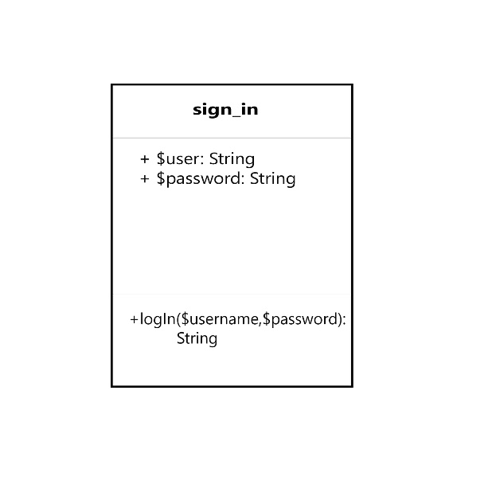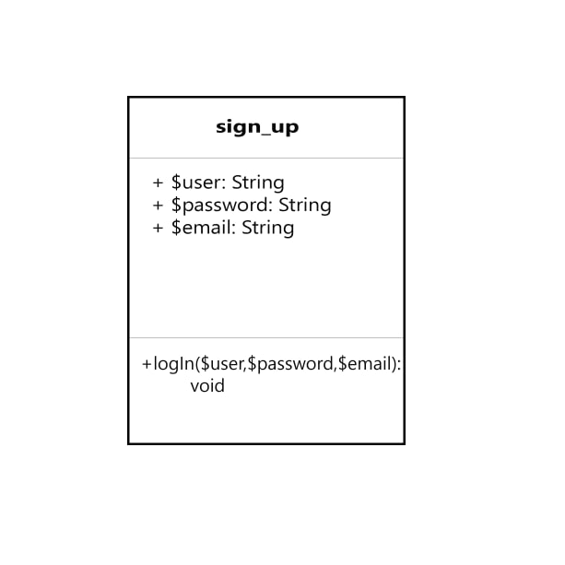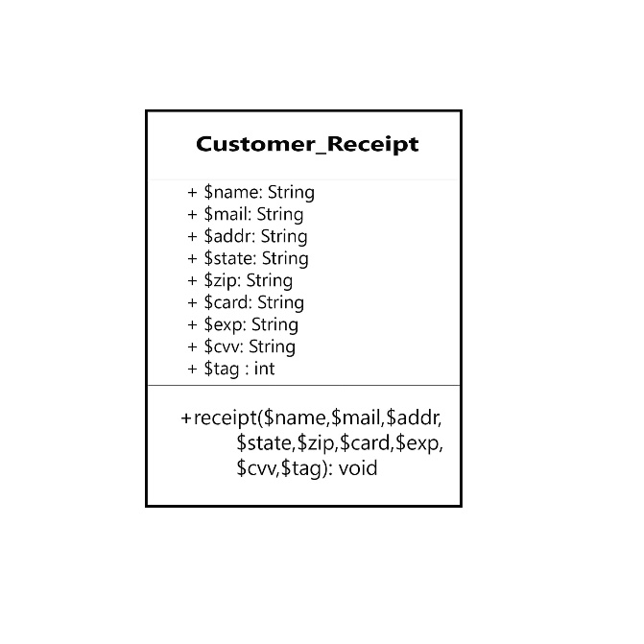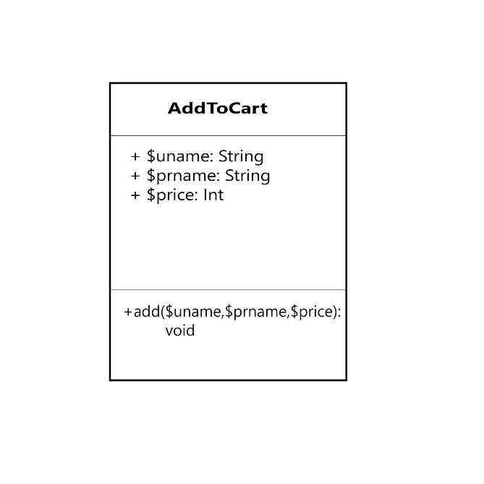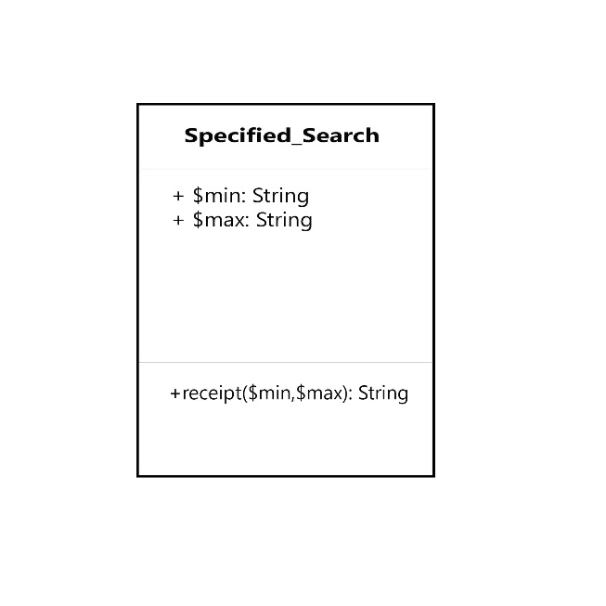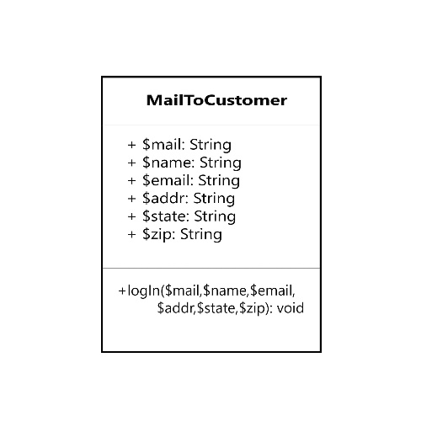

**Sequence Diagram**:

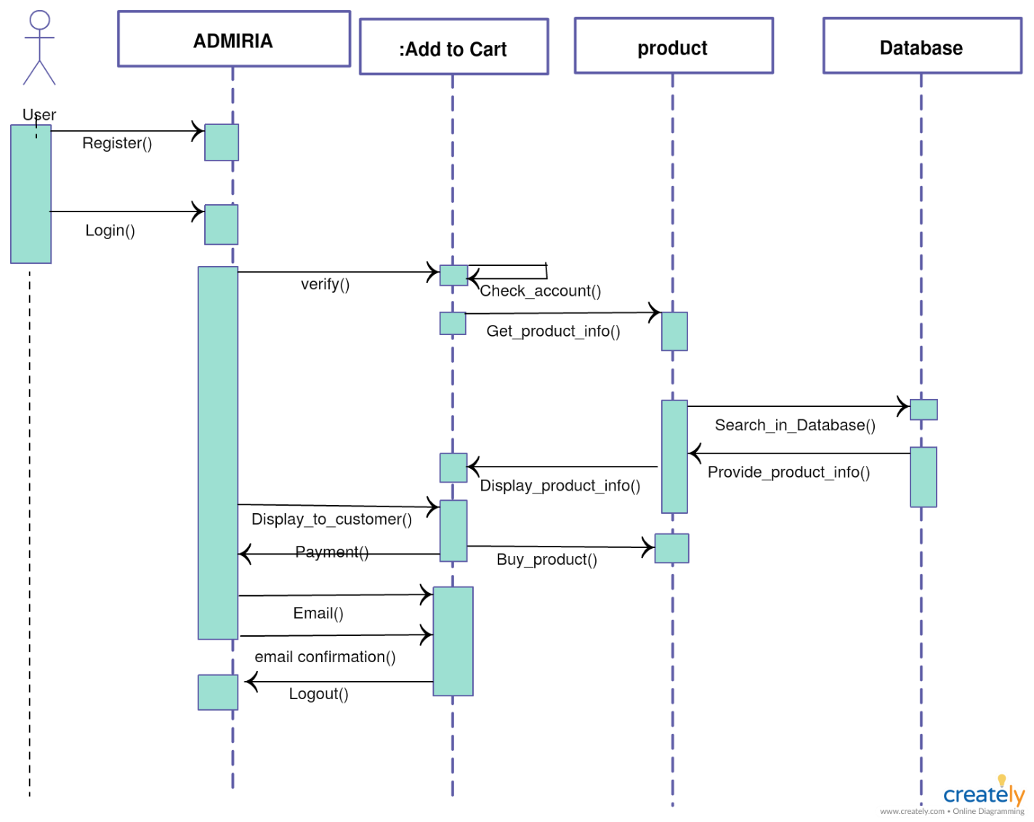

N.B: It was done by creately website editor.

**Software/Tools**:

1. XAMPP
2. phpMyAdmin
3. MySQL
4. HTML
5. CSS
6. PHP

Conclusion:

We hope we have implemented all the functionalities we promised before in the outline.